The physical design that I will be talking about is the lock pictured below

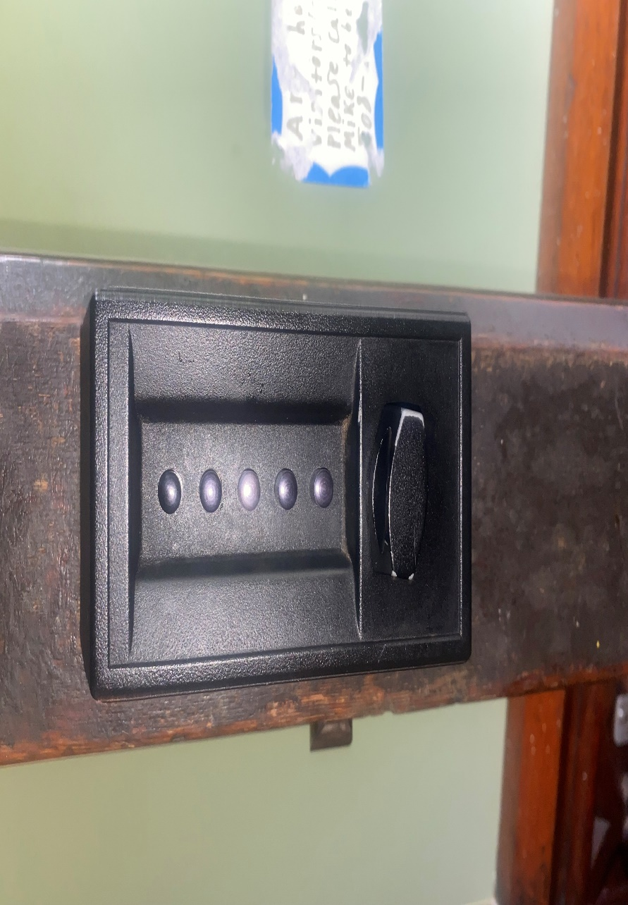

An **Affordance** simply means what can be done with an object, and the use doesn’t only mean what the device was originally created for, take a stapler for example. Under normal circumstances, it would be used to staple something together whether it be paper or other types of materials, but it could also be used as a paperweight, a ruler, or a marker of some sort. There is not really a limit as to what kind of **Affordance** a device may have, it is all dependent on the user's knowledge, skills, strength, etcetera. This object however has an objective only one **Affordance**, which is quite simply being used to lock a door, but even with that, it fails to prepare users on how to use it. The lock does have good **Visibility** though, **Visibility** in this definition is just if something is visible or stands out, and to me, **Visibility** and **Mapping** are very intertwined. Now **Mapping** is the relationship between controls and actions, and the reason why I stated that both **Mapping** and **Visibility** are intertwined is because a lot of the technology we use now have similar **Mappings** as long as they belong to the same category, and because of this we can subconsciously pick on how certain things operate as long as we can see something on it that follows that traditional **Mapping.** Think about the times you’ve gotten something like a new phone or iPad, as soon as you see how the buttons are laid out you quickly figure out which ones are the power button and volume controls. Now the reason why I said the lock from before has good **Visibility** is that all of the buttons along with the knob stand out a lot, making sure that the user can quickly notice each singular component, the **Mapping** is also passable to an extent, as you simply just have to push the buttons with the corresponding password and then turn the knob to open the door, there is a reason as to why I didn’t state that it passed **Mapping** right off the bat and that has to deal with the **Signifiers** of it. Now a **Signifier** is an indicator that helps the user figure out what they can do with that piece of technology. An easy example of a **Signifier** is one we see almost every day which is the push or pull signs that can be found on some doors to tell users what action they must take to open the door. Now **Signifiers** don’t only need to be signs, they could also be things such as marks, symbols, and sounds. The **Signifiers** for this lock are horrible, it has no indication that two buttons can be pressed at the same time to count as one, also the knob can be turned in both directions, turning to the right unlocks it, while the left resets that. There is no way of knowing this just from looking at the lock, you would have needed this information to be told to you beforehand. The last thing I will talk about is the **Feedback** of the lock. **Feedback** information back to the user about the state of the device or the effect of the actions. An example of this would be the sound a bike might make when you are changing its gears. From hearing this explanation you would think that a lock that doesn’t use any keys has some sort of **Feedback**, but it doesn’t. The lock producing some kind of sound that allows users to know if the door can be opened would be great, but this lock doesn’t even do that. All of these reasons is why I believe that this lock truly belongs in the Design Hall of Shame.